Interface Requirement Specification

TV Connected _ TDAL_ANA_INPUT

Iwedia

Version V 1.3, 2009-10-21

Author: Guy Scruignec

Evolutions
Version | Date | Status | Comment
V0.1 | 2008-08-27 | DRAFT | GS _ First draft
V0.2 | 2008-09-02 | DRAFT | GS _ 2nd draft
V0.3 | 2008-09-29 | DRAFT | GS _ Updates after review
V0.4 | 2008-10-08 | DRAFT | GS _ Some correction in “Interactions with TDAL_ANA_VID” chapter
V1.0 | 2008-10-15 | RELEASE | BLE
V1.1 | 2009-02-18 | RELEASE | YP – Remove TDAL_ANA_INPUT_AudioLRModeSet  Cause already in TDAL_ANA_Aud
V1.2 | 2009-09-22 | RELEASE | GS – Add TDAL_ANA_INPUT_MuxCapabilityGet to get input list per multiplexer
V1.3 | 2009-10-13 | RELEASE | GS – Add dependency with TDAL_ANA_AUD module. No API change.

SUMMARY

1 INTRODUCTION 4
1.1 REFERENCE DOCUMENTS 4
1.2 DEFINITIONS, ACRONYMS AND ABBREVIATIONS 4
1.3 OVERVIEW 4
2 TDAL_ANA_INPUT DESCRIPTION 5
2.1 DESCRIPTION 5
2.1.1 General 5
2.1.2 Input object 6
2.1.3 Interactions with TDAL_ANA_VID module 6
2.2 STATIC DIAGRAM 6
2.2.1 Supported features 6
2.2.2 Unsupported features 6
2.2.3 API functions description 7
2.2.3.1 Generic part 7
2.2.3.2 Management part 7
2.2.4 Interface definition 7
2.2.4.1 Type Specifications 7
2.2.5 External dependencies list 7
2.2.6 Memory consumption and performance 7
3 TDAL_ANA_INPUT DYNAMIC BEHAVIOUR 8
3.1 Several audio video input selection 8
4 TDAL_ANA_INPUT API SPECIFICATION 9
4.1 MACRO/DEFINE/ENUM/TYPEDEF/STRUCTURE/UNION DEFINITIONS 9
4.1.1 Define Definitions 9
4.1.1.1 kTDAL_ANA_INPUT_MASK_CLASS 9
4.1.1.2 kTDAL_ANA_INPUT_MASK_TYPE 9
4.1.1.3 kTDAL_ANA_INPUT_MASK_INSTANCE 9
4.1.1.4 kTDAL_ANA_INPUT_NO_OBJECT 9
4.1.1.5 mTDAL_ANA_INPUT_GetObjectId 9
4.1.1.6 mTDAL_ANA_INPUT_GetObjectClass 9
4.1.1.7 mTDAL_ANA_INPUT_GetObjectType 9
4.1.1.8 mTDAL_ANA_INPUT_GetObjectInstance 9
4.1.2 Enum Definitions 10
4.1.2.1 Object class 10
4.1.2.2 Object type 10
4.1.2.3 tTDAL_ANA_INPUT_Error 10
4.1.3 Typedef definitions 10
4.1.3.1 tTDAL_ANA_INPUT_Object 10
4.1.4 Structure Definitions 11
4.1.4.1 tTDAL_ANA_INPUT_Capability 11
4.1.4.2 tTDAL_ANA_INPUT_MuxCapability 12
4.1.5 Union Definitions 12
4.2 API FUNCTIONS 13
4.2.1 Generic API 13
4.2.1.1 TDAL_ANA_INPUT_Init(-) 13
4.2.1.2 TDAL_ANA_INPUT_Term(-) 14
4.2.1.3 TDAL_ANA_INPUT_CapabilityGet(-) 15
4.2.1.4 TDAL_ANA_INPUT_MuxCapabilityGet(-) 16
4.2.1.5 TDAL_ANA_INPUT_APIRevisionGet(-) 16
4.2.1.6 TDAL_ANA_INPUT_PlatformRevisionGet(-) 17
4.2.2 Management API 18
4.2.2.1 TDAL_ANA_INPUT_VideoInputSelect(-) 18
4.2.2.2 TDAL_ANA_INPUT_HandleGet(-) 19
4.2.2.3 TDAL_ANA_INPUT_AudioInputSelect(-) 20
5 TDAL_ANA_INPUT EXTERNAL DEPENDENCIES 21

- INTRODUCTION

  - REFERENCE DOCUMENTS
The following documents were used to write this specification:

Document | Version
[TDAL_ANA_VID] Interface Requirement Specification TV Connected - TDAL_ANA_VID | V1.3
[TDAL_ANA_AUD] Interface Requirement Specification TV Connected - TDAL_ANA_AUD | V1.1

  - DEFINITIONS, ACRONYMS AND ABBREVIATIONS
ADC | Analog to Digital Converter
AV | Audio Video
CVBS | Composite Video, Blanking, Synchronization: (Video format where luminance, chrominance, blanking, and synchronization are integrated in one signal)
COMP | Component Video Input (Video format where color information is transmitted in 3 different signals)
LR | Left Right
YC | Video format where color information is transmitted in a luminance (Y) and one chrominance (C) signal

  - OVERVIEW
The purpose of this document is to specify the abstraction layer targeted to manage the TV analog inputs. This layer acts as a source selector for analog video/audio pins.

- TDAL_ANA_INPUT DESCRIPTION

  - DESCRIPTION

    - General

The function of the TDAL_ANA_INPUT is to select a specific video/audio input source to be routed thus acting as a sources selector.
A schematic representation of the data flow through the TDAL_ANA_INPUT is described in the following figure.
TDAL_ANA_INPUT can have several multiplexers:
- Video Multiplexer: This can take either CVBS or YC or COMP as input and give one output to the video decoder (either composite or component).
- Audio Multiplexer: This can take baseband LR input and outputs digitized audio. It is used to select the audio from AV extensions.

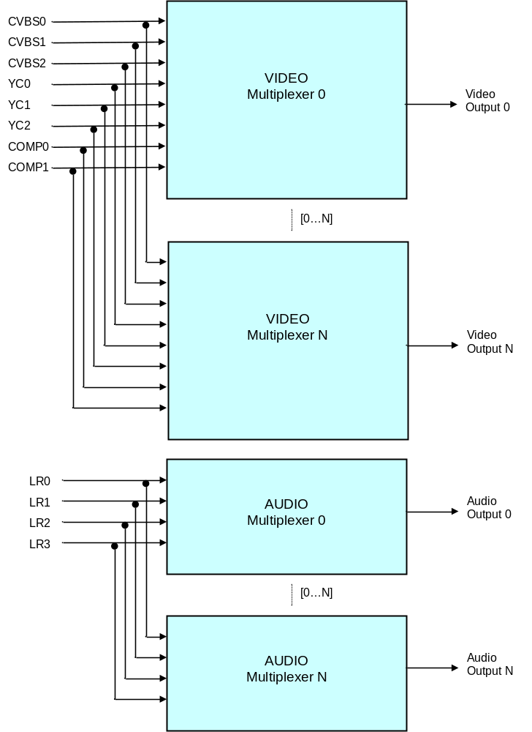

    - Input object
The concept of TDAL_ANA_INPUT object is used. A TDAL_ANA_INPUT object represents different types of hardware piece (video input, audio input, multiplexer…) instance. This instance is also classified as a video or audio object.

Each input objects can be connected or not to several multiplexer of the same class. At a minimum, one input object has to be connected to one multiplexer.

    - Interactions with TDAL_ANA_VID and TDAL_ANA_AUD module
TDAL_ANA_INPUT needs an access to the decoder of TDAL_ANA_VID/TDAL_ANA_AUD to indicate in which video/audio decoder, the video/audio input chosen result must be sent.
For that purpose and to have a complete independence between the TDAL_ANA_VID, TDAL_ANA_AUD, TDAL_ANA_INPUT and other TDAL APIs, the notion of input handle is used. The input handle is an unique opaque value that is used as accessor to a specific input muliplexer. This handle is used transversely between the different TDAL modules in order to authorize a TDAL module to access the low level driver that manages the decoders.
See [TDAL_ANA_VID] and [TDAL_ANA_AUD] for more details.
  - STATIC DIAGRAM

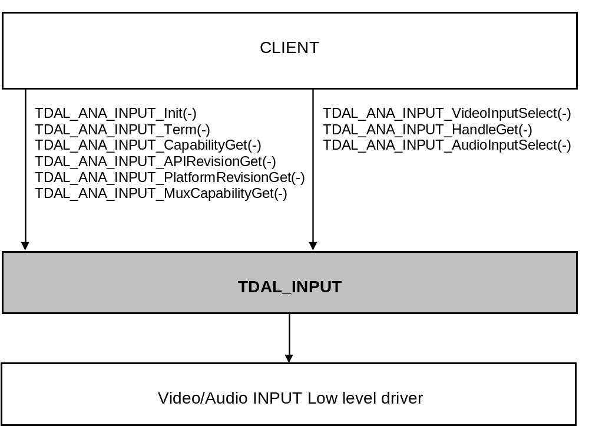

    - Supported features

None.

    - Unsupported features
None.

    - API functions description

      - Generic part

The generic interface allows clients to control the TDAL_ANA_INPUT module.
This interface is used with the following functions:
- TDAL_ANA_INPUT_Init(-) in order to initialize the TDAL_ANA_INPUT module.
- TDAL_ANA_INPUT_Term(-) in order to terminate the TDAL_ANA_INPUT module.
- TDAL_ANA_INPUT_CapabilityGet(-) in order to get the capabilities of the current implementation of TDAL_ANA_INPUT module.
- TDAL_ANA_INPUT_MuxCapabilityGet(-) in order to get the capabilities of the requested multiplexer.
- TDAL_ANA_INPUT_APIRevisionGet(-) in order to retrieve the version of the TDAL_ANA_INPUT API.
- TDAL_ANA_INPUT_PlatformRevisionGet(-) in order to retrieve the version of the TDAL_ANA_INPUT platform implementation.
      - Management part
This interface part allows clients to configure the TDAL_ANA_INPUT module.
This interface is used with the following functions:
- TDAL_ANA_INPUT_VideoInputSelect(-) in order to select the setting of the video multiplexer.
- TDAL_ANA_INPUT_HandleGet(-) in order to to get an opaque unique handle on a stream.
- TDAL_ANA_INPUT_AudioInputSeletect(-) in order to select the setting of the audio multiplexer.
    - Interface definition

      - Type Specifications

The object identifier tTDAL_ANA_INPUT_Object is the way used by an application to access in a single way a specific TDAL_ANA_INPUT object.
Some macros are defined to get some information on an object:
- mTDAL_ANA_INPUT_GetObjectClass(object) to get the class (video or audio) of a TDAL_ANA_INPUT object.
- mTDAL_ANA_INPUT_GetObjectType(object) to get the type (CVBS, YC, COMP, LR, MUX) of a TDAL_ANA_INPUT object.
- mTDAL_ANA_INPUT_GetObjectInstance(object) to get the instance (0,…,n) of a TDAL_ANA_INPUT object.
- mTDAL_ANA_INPUT_GetObjectId(class, type , instance) to get the object from its class, type and instance.

Below are the other type definitions;
- tTDAL_ANA_INPUT_Error is defined to identify an error of the TDAL_ANA_INPUT interface.
- tTDAL_ANA_INPUT_Capability is defined to get the capabilities of the TDAL_ANA_INPUT current implementation.
- tTDAL_ANA_INPUT_MuxCapability is defined to get the capabilities of the requested multiplexer.

    - External dependencies list
None.
    - Memory consumption and performance
The TDAL_ANA_INPUT client must allocate the pointer parameters when needed. It can release the pointer when the TDAL_ANA_INPUT called function has returned.
- TDAL_ANA_INPUT DYNAMIC BEHAVIOUR
  - Several audio video input selection
TDAL client needs:
- To know the number of input object instance available.
- To select 1st audio/video input choice CVBS0 + LR0
- To select 2nd audio/video input choice COMP0 + LR1
- To select 3rd audio/video input choice CVBS0 + LR0 again.

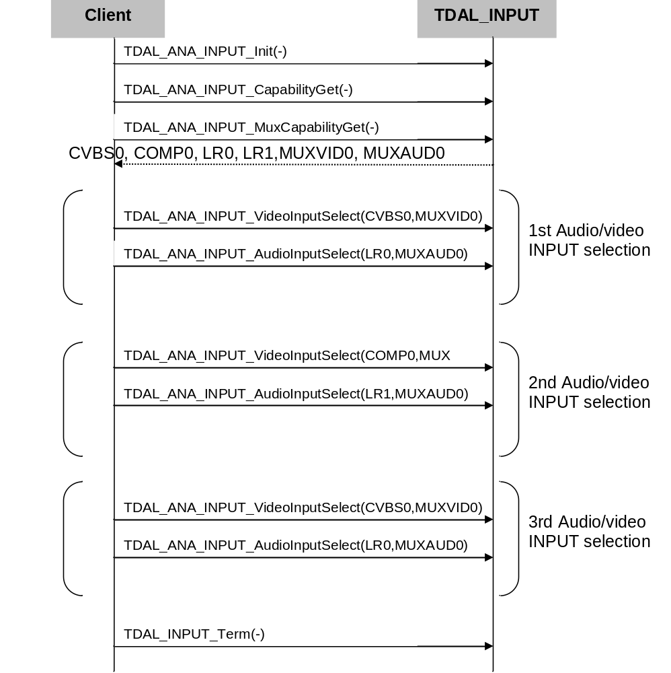
- TDAL_ANA_INPUT API SPECIFICATION

  - MACRO/DEFINE/ENUM/TYPEDEF/STRUCTURE/UNION DEFINITIONS

    - Define Definitions
      - kTDAL_ANA_INPUT_MASK_CLASS
This constant is used to define the class mask of an input object.
#define kTDAL_ANA_INPUT_MASK_CLASS 0xff0000
      - kTDAL_ANA_INPUT_MASK_TYPE
This constant is used to define the type mask of an input object.
#define kTDAL_ANA_INPUT_MASK_TYPE 0x00ff00
      - kTDAL_ANA_INPUT_MASK_INSTANCE
This constant is used to define the instance mask of an input object.
#define kTDAL_ANA_INPUT_MASK_INSTANCE 0x0000ff
      - kTDAL_ANA_INPUT_NO_OBJECT
This constant is used to define the object invalid value.
#define kTDAL_ANA_INPUT_NO_OBJECT 0xFFFFFF
      - mTDAL_ANA_INPUT_GetObjectId
This macro is used to get the object from its class, type and instance.
#define mTDAL_ANA_INPUT_GetObjectId( class , type , instance ) \
(class << 16) + (type << 8) + instance
      - mTDAL_ANA_INPUT_GetObjectClass
This macro is used to get the class (video or audio) of a TDAL_ANA_INPUT object.
#define mTDAL_ANA_INPUT_GetObjectClass( object ) \
(object & kTDAL_ANA_INPUT_MASK_CLASS) >> 16
      - mTDAL_ANA_INPUT_GetObjectType
This macro is used to get the type (CVBS, YC, COMP, LR, SIF) of a TDAL_ANA_INPUT object.
#define mTDAL_ANA_INPUT_GetObjectType( object ) \
(object & kTDAL_ANA_INPUT_MASK_TYPE) >> 8
      - mTDAL_ANA_INPUT_GetObjectInstance
This macro is used to get the instance (0,…,n) of a TDAL_ANA_INPUT object
#define mTDAL_ANA_INPUT_GetObjectInstance( object ) \
(object & kTDAL_ANA_INPUT_MASK_INSTANCE)
    - Enum Definitions
      - Object class
An enumeration of the different object class.
enum {
eTDAL_ANA_INPUT_CLASS_VIDEO = 0 ,
eTDAL_ANA_INPUT_CLASS_AUDIO
};

      - Object type
An enumeration of the different object type.
enum {
eTDAL_ANA_INPUT_TYPE_MUX = 0, /* Muliplexer object type */
eTDAL_ANA_INPUT_TYPE_CVBS, /* CVBS video input object type */
eTDAL_ANA_INPUT_TYPE_YC, /* YC video input object type */
eTDAL_ANA_INPUT_TYPE_COMP, /* Component video input object type */
eTDAL_ANA_INPUT_TYPE_LR /* LR baseband audio input object type */
};

      - tTDAL_ANA_INPUT_Error
An enumeration of the different possible errors generated by TDAL_ANA_INPUT module.
typedef enum
{
eTDAL_ANA_INPUT_NO_ERROR, /* No Error returned */
eTDAL_ANA_INPUT_NOT_INIT_ERROR, /* TDAL_ANA_INPUT has not been initialised */
eTDAL_ANA_INPUT_ALREADY_INIT_ERROR, /* TDAL_ANA_INPUT already initialised */
eTDAL_ANA_INPUT_BAD_ARG_ERROR, /* Bad parameter given to the function */
eTDAL_ANA_INPUT_DRIVER_ERROR, /* Low level driver returns an error */
eTDAL_ANA_INPUT_NO_MEMORY_ERROR, /* Not enough memory to perform action*/
eTDAL_ANA_INPUT_NOT_AVAILABLE_ERROR /* Feature not available*/
}tTDAL_ANA_INPUT_Error;

    - Typedef definitions

      - tTDAL_ANA_INPUT_Object
This typedef defines an input object.
typedef uint32_t tTDAL_ANA_INPUT_Object;

    - Structure Definitions

      - tTDAL_ANA_INPUT_Capability
Description:

This structure defines the capabilities of a TDAL_ANA_INPUT implementation.

Definition:

typedef struct TDAL_ANA_INPUT_Capability_s
{
uint8_t nbInput;
tTDAL_ANA_INPUT_Object *InputArray;
uint8_t nbMux;
tTDAL_ANA_INPUT_Object *MuxArray;
} tTDAL_ANA_INPUT_Capability;

Elements:

Field | Type | Description
nbInput | uint8_t | Number of available input objects
InputArray | tTDAL_ANA_INPUT_Object * | Pointer to array of the available input objects. The number of element in the array is nbInput value.
nbMux | uint8_t | Number of available multiplexer objects
MuxArray | tTDAL_ANA_INPUT_Object * | Pointer to array of the available multiplexer objects. The number of element in the array is nbMux value.

Comments:

The number of input objects are the all available audio/video inputs of the platform.

See Also:
TDAL_ANA_INPUT_CapabilityGet(-)
      - tTDAL_ANA_INPUT_MuxCapability
Description:

This structure defines the capabilities of a specifi multiplexer.

Definition:

typedef struct TDAL_ANA_INPUT_MuxCapability_s
{
uint8_t nbInput;
tTDAL_ANA_INPUT_Object *InputArray;
} tTDAL_ANA_INPUT_MuxCapability;

Elements:

Field | Type | Description
nbInput | uint8_t | Number of available input objects
InputArray | tTDAL_ANA_INPUT_Object * | Pointer to array of the available input objects. The number of element in the array is nbInput value.

Comments:

The number of input objects are the available audio or video inputs of a specific multiplexer.

See Also:
TDAL_ANA_INPUT_MuxCapabilityGet(-).

    - Union Definitions
None.
  - API FUNCTIONS

    - Generic API

      - TDAL_ANA_INPUT_Init(-)
Prototype:

tTDAL_ANA_INPUT_Error TDAL_ANA_INPUT_Init (void);

Description:

This function initialises the TDAL_ANA_INPUT module.

Return value:

It returns eTDAL_ANA_INPUT_NO_ERROR if initialization succeed.
It could be eTDAL_ANA_INPUT_ALREADY_INIT_ERROR, eTDAL_ANA_INPUT_DRIVER_ERROR or eTDAL_ANA_INPUT_NO_MEMORY_ERROR otherwise.

Parameters:

None.

Comments:

This function must be called before any other functions of the TDAL_ANA_INPUT API.

See Also:
TDAL_ANA_INPUT_Term(-)
      - TDAL_ANA_INPUT_Term(-)
Prototype:

tTDAL_ANA_INPUT_Error TDAL_ANA_INPUT_Term (void);

Description:

This function terminates the TDAL_ANA_INPUT module.

Return value:

It returns eTDAL_ANA_INPUT_NO_ERROR if termination succeed.
It could be eTDAL_ANA_INPUT_NOT_INIT_ERROR, eTDAL_ANA_INPUT_DRIVER_ERROR otherwise.

Parameters:

None.

Comments:

Any function of TDAL_ANA_INPUT API should not be called after TDAL_ANA_INPUT_Term(-) call.

See Also:
TDAL_ANA_INPUT_Init(-)
      - TDAL_ANA_INPUT_CapabilityGet(-)
Prototype:

tTDAL_ANA_INPUT_Error TDAL_ANA_INPUT_CapabilityGet
(
tTDAL_ANA_INPUT_Capability *pstCapability
);

Description:

This function retrieves the capabilities of the TDAL_ANA_INPUT current implementation.

Return value:

It returns eTDAL_ANA_INPUT_NO_ERROR if retrieve of capabilities succeed.
It could be eTDAL_ANA_INPUT_NOT_INIT_ERROR, eTDAL_ANA_INPUT_DRIVER_ERROR, eTDAL_ANA_INPUT_BAD_ARG_ERROR otherwise.

Parameters:

Parameter | Type | Dir | Description
pstCapability | tTDAL_ANA_INPUT_Capabilities * | In/out | In: Allocated capability structure pointer.  Out: Structure filled with capabilities of the implementation of the TDAL_ANA_INPUT module.

Comments:

This function can be called at any time the TDAL_ANA_INPUT has been initialised with TDAL_ANA_INPUT_Init(-) but not after the termination with TDAL_ANA_INPUT_Term(-).

See Also:
tTDAL_ANA_INPUT_Capability
      - TDAL_ANA_INPUT_MuxCapabilityGet(-)
Prototype:

tTDAL_ANA_INPUT_Error TDAL_ANA_INPUT_MuxCapabilityGet
(
tTDAL_ANA_INPUT_Object MuxId
tTDAL_ANA_INPUT_MuxCapability *pstMuxCapability
);

Description:

This function retrieves the capabilities of the requested multiplexer.

Return value:

It returns eTDAL_ANA_INPUT_NO_ERROR if retrieve of capabilities succeed.
It could be eTDAL_ANA_INPUT_NOT_INIT_ERROR, eTDAL_ANA_INPUT_DRIVER_ERROR, eTDAL_ANA_INPUT_BAD_ARG_ERROR otherwise.

Parameters:

Parameter | Type | Dir | Description
pstMuxCapability | tTDAL_ANA_INPUT_MuxCapabilities * | In/out | In: Allocated capability structure pointer.  Out: Structure filled with capabilities of the multiplexer.

Comments:

This function can be called at any time the TDAL_ANA_INPUT has been initialised with TDAL_ANA_INPUT_Init(-) but not after the termination with TDAL_ANA_INPUT_Term(-).

See Also:
tTDAL_ANA_INPUT_MuxCapability.

      - TDAL_ANA_INPUT_APIRevisionGet(-)
Prototype:

const char *TDAL_ANA_INPUT_APIRevisionGet(void);

Description:

This function retrieves the API revision.

Return value:

A string containing the revision of the TDAL_ANA_INPUT API.

Parameters:

None.

Comments:

This function can be called at any time.

See Also:

      - TDAL_ANA_INPUT_PlatformRevisionGet(-)
Prototype:

const char *TDAL_ANA_INPUT_PlatformRevisionGet(void);

Description:

This function retrieves the platform implementation revision.

Return value:

A string containing the revision of the TDAL_ANA_INPUT implementation on a platform.

Parameters:

None.

Comments:

This function can be called at any time.

See Also:

    - Management API

      - TDAL_ANA_INPUT_VideoInputSelect(-)
Prototype:

tTDAL_ANA_INPUT_Error TDAL_ANA_INPUT_VideoInputSelect
(
tTDAL_ANA_INPUT_Object InputId,
tTDAL_ANA_INPUT_Object MuxId
);

Description:

This function selects the input setting of the video multiplexer.

Return value:

It returns eTDAL_ANA_INPUT_NO_ERROR if s succeed.
It could be eTDAL_ANA_INPUT_NOT_INIT_ERROR, eTDAL_ANA_INPUT_DRIVER_ERROR, eTDAL_ANA_INPUT_BAD_ARG_ERROR otherwise.

Parameters:

Parameter | Type | Dir | Description
InputId | tTDAL_ANA_INPUT_Object | In | Video class input object identifier
MuxId | tTDAL_ANA_INPUT_Object | In | Video class multiplexer object identifier

Comments:

This function can be called at any time the TDAL_ANA_INPUT has been initialised with TDAL_ANA_INPUT_Init(-) but not after the termination with TDAL_ANA_INPUT_Term(-).

See Also:
tTDAL_ANA_INPUT_Object

      - TDAL_ANA_INPUT_HandleGet(-)
Prototype:

tTDAL_ANA_INPUT_Error TDAL_ANA_INPUT_HandleGet
(
tTDAL_ANA_INPUT_Object MuxId,
void *pHandle
);

Description:

This function is used to get an opaque unique handle on the input mulitplexer.

Return value:

It returns eTDAL_ANA_INPUT_NO_ERROR if s succeed.
It could be eTDAL_ANA_INPUT_NOT_INIT_ERROR, eTDAL_ANA_INPUT_DRIVER_ERROR, eTDAL_ANA_INPUT_BAD_ARG_ERROR otherwise.

Parameters:

Parameter | Type | Dir | Description
MuxId | tTDAL_ANA_INPUT_Object | In | Multiplexer object identifier
pHandle | void * | In/Out | In: pointer to a layer handle.  Out: unique input handle.

Comments:
The opaque handle is typically used in other TDAL modules which needs to link information to the input (analog video decoder, …). For more details, see chapter “Interactions with TDAL_ANA_VID and TDAL_ANA_AUD module”.

See Also:

tTDAL_ANA_INPUT_Object.

      - TDAL_ANA_INPUT_AudioInputSelect(-)
Prototype:

tTDAL_ANA_INPUT_Error TDAL_ANA_INPUT_AudioInputSelect
(
tTDAL_ANA_INPUT_Object InputId,
tTDAL_ANA_INPUT_Object MuxId
);

Description:

This function selects the input setting of the audio multiplexer.

Return value:

It returns eTDAL_ANA_INPUT_NO_ERROR if s succeed.
It could be eTDAL_ANA_INPUT_NOT_INIT_ERROR, eTDAL_ANA_INPUT_DRIVER_ERROR, eTDAL_ANA_INPUT_BAD_ARG_ERROR otherwise.

Parameters:

Parameter | Type | Dir | Description
InputId | tTDAL_ANA_INPUT_Object | In | Audio class and LR type input object identifier
MuxId | tTDAL_ANA_INPUT_Object | In | Audio class multiplexer object identifier

Comments:

This function can be called at any time the TDAL_ANA_INPUT has been initialised with TDAL_ANA_INPUT_Init(-) but not after the termination with TDAL_ANA_INPUT_Term(-).

See Also:
tTDAL_ANA_INPUT_Object

- TDAL_ANA_INPUT EXTERNAL DEPENDENCIES
None.

